CTI Clonmel

Raheen College Gaelcholáiste Chéitínn
Senior College

Draft School Policy
on

Drugs/Substance Abuse

Updated in March 2018

INTRODUCTION TO THE POLICY

Mission Statement

The Role of our school is to facilitate the students and people of Clonmel and its environs in the acquisition of general and specialised education.
We seek:
- To encourage the development of the full person through imparting knowledge and skills and through inculcating values:
- To develop critical thinking faculties and to promote informed decision-making skills in students.
- To bring students to an awareness of their identity in a multi-denominational, multi-cultural context;
- To enable the transition to further education;
- To encourage the participation of parents in the education of their children;
- To respond to the educational needs of the local community.

The School's Position
The school's position is to provide a health promoting ethos and environment where consumption of and dealing in drugs is strictly forbidden as per Rule 8 of our Code of Behaviour. This rule is in keeping with what is laid down in the Misuse of Drugs Act It has been agreed that a drug is "Any substance which changes the way a person functions, be that mentally, physically and/or emotionally".
This school recognises the reality that drugs -both legal and illegal- are available in the local community and that the school has and will have, accordingly, drug incidents which will need to be handled in a consistent, fair and sensible way. This school also acknowledges that it has an important role to play in drugs education both in terms of prevention and in offering support to those who use drugs.

The School Ethos

In line with our Mission Statement, the school ethos is to promote the physical, emotional, psychological, spiritual and social well-being of students entrusted to our care. Ours is a holistic approach to all students in our school. This ethos underpins and informs all the work we do and is central to this policy document. Many of our school policies are linked into and support our School Policy on Drugs. Some of these include:
- Pastoral Care Policy
- Code of Behaviour
- Critical Incident Management Policy
- Guidance Policy
- Well-Being Policy (Currently under development)
- Child Protection Policy/Child Safeguarding Statement
- Policy on attendance
- Mobile Phone Policy
- I.C.T Policy
- Anti-Bullying Policy
- Health and Safety Policy
- Administration of medicines Policy
Define School
Under this policy we define our school as a community of people involved in the process of learning. Respect for persons is the foundation on which our school community is built. The community comprises all those students who are registered in our school, and their parents, and those who work in the school.
The definition of the school also extends to cover the following:
- The physical buildings at Raheen Road, its environs and boundaries.
- The physical buildings at the Mall, its environs and boundaries.
- The roadway between Raheen Road and the Mall.
- Any trip, excursion or outing W1dertaken by a group or individual representing the school community.

We believe that the needs of the whole school community and all associated persons must be addressed in relation to drugs and this school is firmly committed to so doing. Co-operation on the part of teachers, parents, Board of Management and students is essential to the acceptance and implementation of the policy.
This policy has been drawn up and agreed to by the teaching staff, management, students, parents and the Board of Management.

The Use of Drugs in School

This school does not, under any circumstances accept or condone the possession, use, supply or dealing of drugs in the school, on school trips or in non-school time by any member of the school community.
The only exception to th.is is for legitimate medicinal use and the following applies:

    - If a student is on prescribed medication, use is allowed in accordance with medical instructions.
    - When a student is suffering from a minor illness, the Principal/Deputy Principal may at his/her discretion give an analgesic e.g. Panadol, to alleviate symptoms. The student is brought home if symptoms persist.
    - Full medical history of students must be provided by parents at enrolment with a list of prescribed medications which the student has to take. Any illness arising subsequent to enrolment and requiring prescribed medication must also be notified to school authorities.

This policy is focused on four key areas:
- Alcohol, Tobacco and Drug Education Programmes
- Managing Drug Related Incidents
- Training and Staff Development
- Monitoring, Review and Evaluation

ALCOHOL, TOBACCO AN· D DRUG EDUCAT ION
PROGRAMMES

The Schools Position
This school is committed to providing a comprehensive and time-tabled drug education programme for all students as part of the Social and Personal Health Education Programme currently running in the school.
Our educational aims in relation to Drug Education are:
- To explain to students the effects drugs can have on the body physically, psychologically, emotionally.
- To explain the effects illegal drugs have socially in terms of the cost to oneself, one's family and society.
- To distinguish in students' minds differences between lawfully prescribed drugs, illegal drugs and legal drugs such as alcohol and tobacco.
- To raise students' awareness of the insidious, illicit nature of the drug culture: its exploitation of people's vulnerabilities.
- To attempt to build students' self-esteem so that they are able to resist peer pressure and other pressures to become involved in the drug scene.
- To examine the secrecy surrounding illegal drug usage.
- To educate students in alternative ways of finding fulfillment in their lives other than having recourse only to stimulants such as alcohol, illegal drugs and tobacco.

The Drug Education Programme will be carried out using methodologies such as: Quizzes; Questionnaires; Surveys; Class Discussion; Case Studies; Videos; Brainstorming - why start? Working in Pairs- Report Back; Designing Posters; Work Sheets and Guest Speakers.
Outside or Guest Speakers give students ano1her and often, very convincing perspective, which reinforces or supplements work done in the classroom. Such speakers include:
- Medical Viewpoint - Health Board Personnel etc.
- Legal viewpoint - Gardai, Juvenile Liaison Officer
- Peer Group i.e. AJateen
- Alcoholics Anonymous, former addicts/alcoholics recommended experts working in the area.
- Addiction Counsellors.

Staff Training
    - All teachers involved in SPHE will be given the opportunity to avail of training in group facilitation skills and personal development.
    - Staff teaching the Drug Education Programme will be given the opportunity to avail of training in The Substance Abuse Prevention Pact (SAPP)-"On My Own Two Feet" Department of Education and Science and the Department of Health and Children.
    - All teachers will be offered Drug Information and Drug Awareness training through regular in-service training.
    - The school's Drug Co-ordinator is the Deputy Principal

Parents

The definition of a parent under this Policy is the person who is the natural or biological parent of the student; the adoptive or foster parent of the student; the guardian or person in charge of the student.
Parents are the primary educators of their children in health education matters.
The school's role and legal obligation is to complement this. Thus parents are to be made aware and informed of what is happening in the school with regard to drug education. This will happen on a yearly basis. Where parents request it, parenting programmes and drug education programmes will be organised and made available by the school to meet their needs.

MANAGING A DRUG RELATED INCIDENT

The School Approach

We acknowledge that in all situations involving drugs, we must keep a balance between the needs of the young person concerned, the needs of the school community and the reputation of the school.
Our initial approach to the situation will be to listen, to separate fact from myth and to offer support. Each case will be dealt with on its own merits. Disciplinary procedures will be called in if the school's Code of Behaviour has been breached. Expulsion is seen by the school as a last resort. This is mandatory where the offence of dealing is established.
The student and the student's well-being are of prime importance. Disclosure of a student’s involvement in drugs will be strictly on a "need to know'' basis.
Procedures are in place to handle specific drug incidents.

Drug Incidents

The following are some examples of drug incidents:

- Student in school in intoxicated state/displaying unusual behaviour.
- Student in uncharacteristically unkempt/deterioration in physical condition and appearance.
- Student indulging in uncontrolled giggling or silli ness.
- Emergencies when student may be unconscious or semi-conscious.
- Drugs or drug paraphernalia found on student on school premises or on a
school related activity.
- Disclosure by another person.
- School grounds being used for drug activity.
- Person seeking help from member of staff.
- Suspicion of drug use, possession or dealing.
- Admission by a student that he/she has consumed an illegal substance

Assessing a Drug Incident

All decisions, actions interventions taken by the school authorities are predicated on ensuring the welfare of the student and the school community. In all cases where there is no immediate danger to the student/s, it is important to take time to assess and evaluate the situation before responding and to complete a drug incident form. Rumour must not be taken as evidence of drug use. Neither must the normal changes and fluctuating moods of adolescence be confused with or interpreted as evidence that the student is involved in drug usage.

Recording Procedure
In situations of confirmed use, possession, sharing, supply or dealing, the drug incident form must be completed. All the details will be recorded and acted upon. A written recording procedure will be used to ensure that a fair process of challenging the student about behaviour of concern is in place. The Principal/Deputy Principal is responsible for recording procedures. A copy of the incident form is in the Appendix. Where any member of staff encounters/witnesses a drug incident, he/she must as soon as practicable, furnish the Principal with a written account.

Managing a Drug Incident
Where there is suspicion that a student is using drugs, the Principal/Deputy Principal will invite parents in and will, with sensitivity, alert them to the situation. They will be asked to take their child to the Child’s G.P.

If a parent/Guardian arrives at the school before the emergency services, responsibility for the student then devolves to the parents. However, where there is an immediate danger, the emergency services should be contacted without hesitation, and the Principal and Deputy Principal should be informed. Parents/Guardians should be informed as soon as possible. Where a student admits to having consumed an illicit substance, the school is obliged to act and will accept this as fact even though no symptoms are immediately apparent. Medical help will be sought and parents contacted as above.

To fulfil the school’s obligation in looking after the students’ welfare and wellbeing, the school will ask/encourage the Parent/Guardian to take their child to their child’s GP.

Where a student has admitted to consuming an illicit substance the school, in the interest of the student’s wellbeing, will insist that the Parent/guardian take their child immediately to the hospital’s A&E/the child’s GP.

Where a second or subsequent suspicion arises that the student is consuming illicit substances, on each occasion the school will alert parents and the parents will be requested to take their child to the child’s GP and furnish the school with a letter from the GP indicating that he/she has seen the student.

Where a Parent/Guardian fails to engage with the school regarding their child’s ongoing consumption of illicit substances, the school under the Child Protection Legislation, is mandated to contact Child Protection Services ie. TUSLA.

The school will expect full parental co-operation in ensuring that their child attends a Drug Rehabilitation Course, that s/he engages with such a course and that s/he completes the course. This course will be organized through the school in agreement with the parents or the parents may choose to organize rehabilitation themselves for their child.

The facilitator of the course may suggest that the student takes time out of school to engage in the course and to recuperate. S/he may alternatively suggest that it is in the student's best interest to continue attending school while participating in the course. The school will be guided by the advice of the facilitator.

The school must receive written or verbal confirmation from the facilitator that the student has attended, engaged with and completed a Drug Rehabilitation Course. If the student refuses to attend, engage with or complete the course, s/he will be suspended from school until s/he chooses to comply with the school's above requirements.

Where a student and his/her parent(s) acknowledge that the student is misusing drugs and there is an agreement that the student will comply with the school's Drugs Policy to attend a rehabilitation course, it is school policy that the student may only return to school with an up-to-date medical certificate confirming that h/she is free of drugs.

Where a student has attended, fully engaged in and completed a drug rehabilitation course, the school will impose certain terms and conditions concerning his/her return to school. These terms and conditions will relate directly to the individual student and may include a probationary period and/or reduced timetable. The student will also be put on a report card.

Where there is any suspicion of further substance misuse i.e consumption and if positive, the case will be referred to the Board of Management. However, in the event of any other form of misuse, i.e. possession, purchasing, sharing, supplying or dealing, expulsion is automatic.
In the situation where a student is caught with illegal drugs on the school premises, the Principal/Deputy Principal will notify the Gardaí. Parents will be made aware that the Gardaí have been/are being infon11ed. Any drugs or any confiscated drugs related paraphernalia will be handed over to the Gardaí.

Students under eighteen years of age require written parental consent to attend a Drug Rehabilitation Course. Where such parental consent is withheld the school will be obliged to suspend the student and notify the Educational Welfare Officer of the suspension and the reason for it. This is a legal requirement (Education Welfare Bill 1999).
Where a student is caught in possession of drugs within the school:
- Drugs will be confiscated and may be handed over to the Gardai.
- Student will be brought immediately to the Principal/Deputy Principal's office.
- Principal/Deputy Principal will notify student's parents and may notify Juvenile Liaison Officer.
- Student will be suspended pending further investigation of incident.
- School will provide full assistance to help student engage in a Drug Rehabilitation Course as already outlined above.

Dealing of drugs by any student within the school (school as defined in this policy) will incur automatic expulsion from the school.

Confidentiality

The school recognises that the issue of confidentiality is complex. No teacher can offer total confidentiality to a student who discloses drug involvement. We recognise the need for care in this area as the student may approach a particular teacher because s/he trusts that teacher and needs help. The way in which situations are handled will have an important bearing on the outcome. Information must remain private and only disclosed strictly on a "need to know" basis. The student must be informed about what is happening and why.
The wellbeing and welfare of the student and the teacher must be the prime focus.

All students need to understand the limits of confidentiality. It is important that this issue be clearly discussed with them before an incident occurs. Such discussion will take place in S.P.H.E. classes at the start of each academic year.

Media
The Principal/Deputy Principal or designated spokesperson will handle all media queries. No comment will be made by this school on any individual case. The school will refer to its policy and procedures in place to manage any drug related incident.

Review and Evaluation
This policy will be reviewed at the end of the academic year in May 2019 by the Drug Policy Working Group in consultation with the wider school community .

Dissemination of Policy

Copies of this policy will be disseminated to the school community and to parents of new students when they enrol in the school.
Students will be made aware of the policy as part of their Substance Use education in SPHE.

REVIEW OF SUBSTANCE MISUSE/DRUGS POLICY 2016 in
COLAISTE CHLUAIN MEALA

A meeting of the Substance Misuse/ Drugs Policy committee took place on the 25/4/2016 to review the operation of the policy in Colaiste Chluain Meala.
The committee recommended that where a student has been found to be in breach of the schools Substance Misuse/Drugs Policy, e.g. in possession of or consuming drugs on the school premises, and has, accordingly, been required to attend, engage with and fully complete a drugs rehabilitation course or has been required to appear before the school's BOM, the student involved will automatically be put on a pe1manent card
This committee insists that where a student is referred to his/her GP to be tested for possible illicit drug/substance misuse, a blood test should be conducted to determine definitively whether substance misuse has occurred. It is this school's experience that urine tests, checking for the presence of illicit d1ug consumption, are open to manipulation by those being tested, this, we suspect on occasion with the tacit collusion of parents. False negative results leave the school in an invidious position, particularly with regard to health and safety of the students whose test results are at variance with what school staff members have observed in terms of how such students had presented themselves and had been behaving. False negative results also have the potential to place other students and staff at risk in terms of health and safety also. Again, false negative test results tend to have a very detrimental influence on the more vulnerable students in their peer group.
The committee also recommends that an in-service on recognising and dealing with substance misuse among students be provided in the coming academic year both for new staff members and to update all staff on current trends regarding drug misuse.

REVIEW of DRUGS POLICY of COLAISTE

CHLUAIN MEALA-16/9/2012

A meeting of the Drugs Policy Committee of Colaiste Chluain Meala to review the school's Drugs Policy was held on the 16/9/2012.
The Drugs Policy Committee clarified that, with regard to point 1 of the review of the Drugs Policy on the 6/12/2011, this point has now been amended as follows:
"Where a student and his/her parent(s) acknowledge that the student is misusing drugs and there is an agreement that the student will comply with the school's Drugs Policy to attend a rehabilitation course, it is school policy that the student may only re-attend the school when he/she produces an up­ to-date medical certificate confirming that he/she is now free of drugs".

Failure of the student and his/her parents to fulfil all the requirements of engaging in the Drugs Rehabilitation Programme as set out in the school's Drugs Policy, and specifically the failure to produce an up-to-date medical certificate confirming that the student is now free from drugs/illicit substances within a timeframe of weeks, means that he/she will be expelled by the BOM.

This timeframe begins from the date on which the school requests that the student undertakes a blood test to determine whether he/she has illicit substances/drugs in his/her system.

This timeframe allows more than adequate time for referral of student to G.P, laboratory tests, return of results to G.P., and if test is positive, time for illicit substances/drugs to have passed through the student's system, retesting and the production of second set of results to the school. It is the parent(s)/guardian's responsibility to ensure that the medical ce1tificate detailing the results of these blood tests is given to the Principal/Deputy Principal within the specified timeframe.
Failure to produce a clear blood test within the specified timeframe indicates that the student is not or is unwilling to be in compliance with the school' s Drugs Policy.

Where a student subsequently re-offends, having completed a Drugs Rehabilitation Programme and the re-offending is confirmed through a blood test, he/she will be expelled by the BOM.

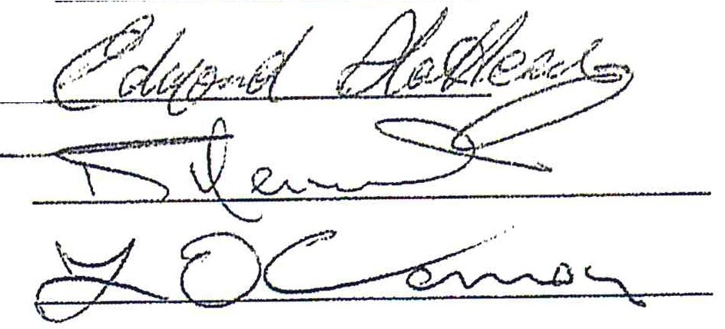
Signed:

Date: 16/09/2012

Colaiste Chluain Meala

Review of Drugs Policy 2011
A meeting of the Drugs Policy Committee, to review the workings of the Drugs
Policy, was held in Colaiste Chluain Meala on the 6th of December 2011. It was decided to amend the Drugs Policy to incorporate the following:

- Where a student and his/her parent(s) acknowledge that the student is misusing drugs and there is an agreement that the student will comply with the school's Drugs Policy to attend a rehabilitation course, it is school policy that the student may only return to school with a medical certificate confirming that he/she has had a blood test indicating that he/she is free of drugs.

- Where a student has attended, fully engaged in and completed a drug rehabilitation course, the school will impose certain terms and conditions concerning his/her return to school. These terms and conditions will relate directly to the individual student and may include a probationary period, reduced timetable, responsibility for lunchtime supervision resting entirely with the parent/guardian. The student will also be put on a report card.
Where there is any suspicion of further substance misuse i.e. consumption, a blood test is mandatory and if positive, the case will be referred to the Board of Management. However, in the event of any other form of misuse, i.e. possession, purchasing, sharing, supplying or dealing, expulsion is automatic.

- In the situation where a student is caught with drugs on the school premises, the Principal/ Deputy Principal will notify the Gardai. Parents will be made aware that the Gardaí have been/are being informed. Any drugs or any confiscated drugs related paraphernalia are will be handed over to the Gardaí.

- Where a student who is a transferee from another school, having a previous history of drug misuse eg. sharing/supplying, dealing, using, or where such a student has been involved in a Drug Rehabilitation Programme, and where such disclosures were not communicated to the school at enrolment and where such a student is subsequently caught in possession of, using, supplying/sharing or dealing in drugs - expulsion is a mandatory sanction

- Sharing/supplying or dealing of drugs by any student in the school, (school as defined by this) policy will incur automatic expulsion from the school.

The Drugs Policy Committee reiterated that greater emphasis needs to be placed on maintaining the balance between:

The needs of the young person concerned
The needs of the school concerned
The reputation of the school

The Drugs Policy Committee recommended that these questions be inserted into the transferee application enrolment form:

Is the applicant currently misusing drugs or has the applicant a history of drug misuse? If yes, has the applicant attended, engaged fully in and completed a Drug Rehabilitation Programme?
Can the applicant prove that he/she is now drug free
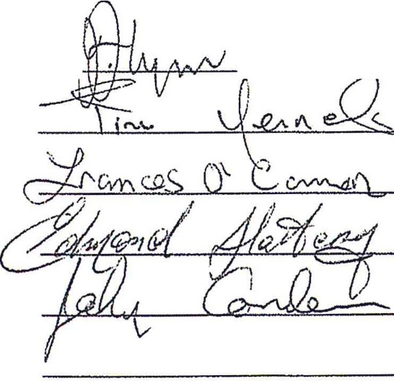
Signed: :, -

REVIEW of DRUGS POLICY of GAELCHOLÁISTE CHÉITINN
The Drugs Policy of Gaelcholáiste Chéitinn was reviewed on the 31/5/2010 and it was considered that the policy had proved to be effective in addressing issues that arose during the school year.
Our policy procedures were fully implemented in relation to dealing with
one particularly serious breach of rule 6 of our Code of Behaviour. This particular case was taken to the BOM. The decision of the board was to follow through with the ultimate sanction as set out in our Drugs Policy and Code of Behaviour and this decision was accepted by all parties.
Continued awareness and vigilance on all our parts in relation to the ever growing availability of illegal substances and the misuse of legal substances is vitally important. Unfortunately, we have to accept the fact that some of our students come from homes where drug abuse is the norm, it being a generational inheritance. Therefore, our vigilance as a staff must be focused on ensuring, in as far as possible, that drugs or substances are not consumed or exchanged by students within the school boundaries. We will continue to work with outside agencies and with parents to provide every support to students involved in substance.
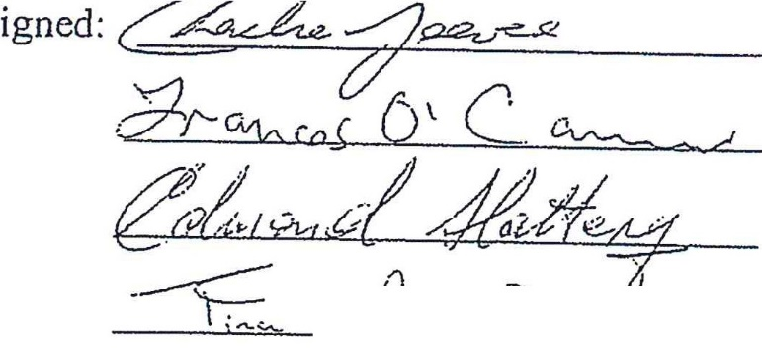
1
.. I
--
..
I

Date: 31/05/2010

